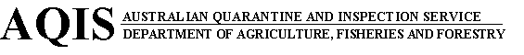

 | Import case details - public listing | New Search

 | Commodity: | Rendered animal fat - Not from ruminant animals
 | Scientific name:
 | Country: | All countries
 | End use: | Human consumption
 | Date printed: | Jul 10 2003

The information here covers AQIS quarantine requirements only and is current on the date of transmission but may change without notice. Importers must satisfy quarantine concerns and comply with quarantine conditions applicable at the time of entry. The Commonwealth through AQIS is not liable for any costs arising from or associated with decisions to import based on conditions presented here which are not current at time of importation.
It is the importer’s responsibility to be aware of and to ensure compliance with the requirements of all other regulatory and advisory bodies prior to and after importation. eg. Australian Customs Service , State Departments of Agriculture, Imported Foods Program, Therapeutic Goods Administration , National Registration Authority for Agricultural and Veterinary Chemicals .

Condition C5100
A Quarantine Entry must be lodged for each consignment and they must be inspected on arrival. The following conditions also apply to the imported goods.
Condition C5206
A Permit application is required prior to importation and must be approved by Canberra Office.
Condition C5006
Animal fat and tallow which is derived from any animal, including rendered fat and tallow from pigs, must be accompanied by a Permit from Canberra on arrival into Australia. The end use of the product needs to be specified when applying for the Permit.
Treatment T9902
Treat as required by the Permit conditions.

